Week 2

Blackboard

Tufte’s principal is about clearing the clutter in visualizations and keeping focus on the data. He believed that dressing up a visualization with unrelated ink or graphics distorts the story of the data. The below link provides a good summary from a previous site owner. (See note in bottom of page)

<https://thedoublethink.com/tuftes-principles-for-visualizing-quantitative-information/>

|  |  |
| --- | --- |
| GOOD | BAD |
|  |  |

|  |
| --- |
| Ref: http://davidgiard.com/2011/05/12/DataVisualizationPart5DataInk.aspx |

I believe his principles applies more to the static images of pre -internet era and to a lesser of degree the current age of data presentation. The objective of keeping the data at the center when presenting visualization should continue to be the focus. However, the interactivity of today’s data presentation requires more graphics to differentiate data from the from the interactive widgets, and account for the velocity of rapidly changing data.

The new generation of users have grown up with graphics, this new era requires a slightly different approach to keep their attention. The CNN article below discusses how the data presented must tell a story while showing how it is relatable and allow users to interact with their own context. The ability to interact and engage with the data is key to providing a story with value.

<http://www.cnn.com/2011/OPINION/04/19/sexy.data/index.html>

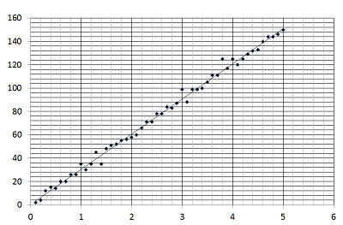

Week 3

Chartjunk refers to visualization that distract from data and provides no value in interpreting the values of the data. In some cases chartjunk can make it more difficult to understand what you are trying to present.

The web has plenty of examples of bad use of visuals. This first link has the 15 worst site that distract site visitors from what the websites original purpose. Some visualization are unrelated to the actual site which can cause confusion or frustration to the vistor.

[WORST WEBSITES EVER](https://webdesignledger.com/worst-websites-ever/2/)

The next site from Business Insider list worst charts of all time.

[WORST CHARTS OF ALL TIME](https://www.businessinsider.com/the-27-worst-charts-of-all-time-2013-6#unordered-perplexingly-circular-and-difficult-to-ascertain-any-information-from-this-globe-and-mail-chart-they-went-out-of-their-way-to-make-this-flashy-but-difficult-to-actually-read-we-get-what-they-were-going-for-but-this-chart-is-precisely-why-humanity-invented-tables-6)

In example below we are not sure what the colors refer to or what the divider mean.

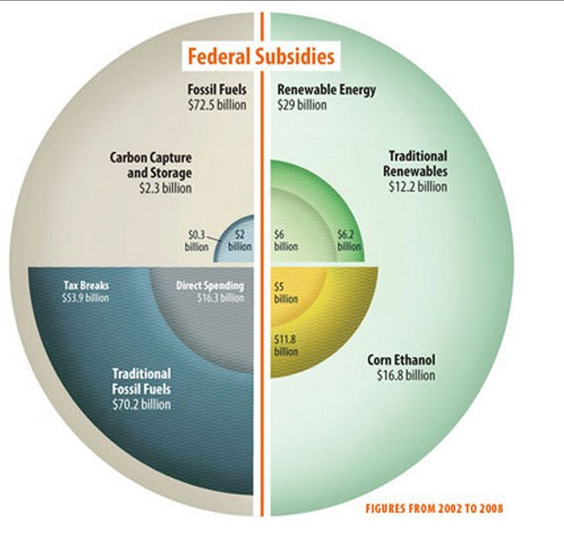

A bad site or bad chart comes down to a visualization that does not provide any value to the intention of the data presentation, chartjunk.

Week 4

Small multiples are small images used to sequence or order quantitative data. With the abundance of data, the small multiples allow multiple aggregations of large data to be displayed on one page.

One issue with small multiples is overplotting as described in below link:

<https://www.displayr.com/what-are-small-multiples/>

In the first example you can see several a view of aggregation of the stores as well as other fields one view. The percentage of price differences between stores gives a clear view, but the additional fields provide no value and result in overplotting

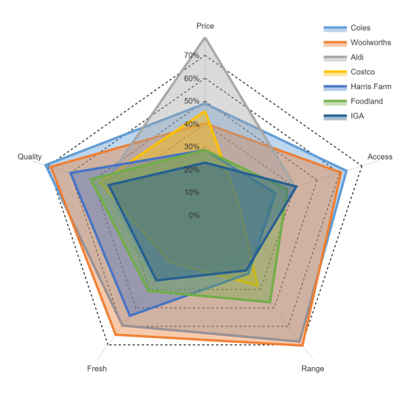

This 2nd example shows how splitting the stores data allow viewers to easily understand how additional price relate to the additional fields.

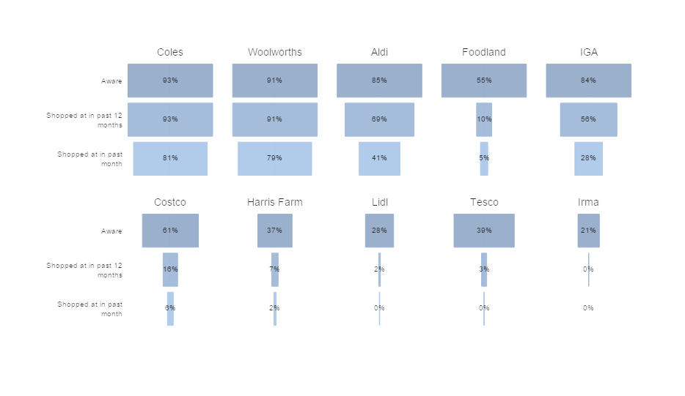  
Small multiples still apply to the web, but there are more interactive options available that allow drill downs to redisplay the filtered data. These interactive options apply more to today’s velocity and variety of data. Some of the tools for interactive drilldown reporting include Crystal Reports, Qlikview, PowerBI, Tableau…etc.

Week 5

Multifunctioning Graphical elements tries to describe data with graphical elements that clear and pleasing to the eyes. It is important to ensure added graphics do not make it more difficult for the viewer to understand the data.

In the example below the graphic is clear that it is describing data on higher life expectancy and lower fertility rate trends

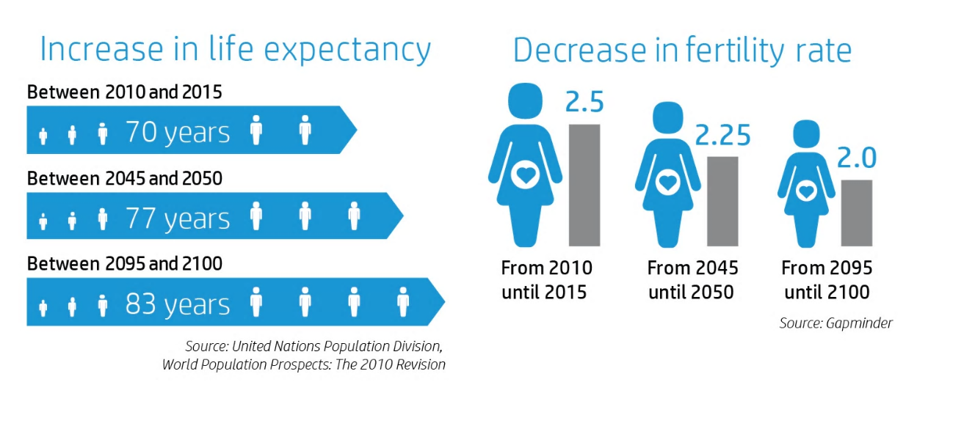

Multifunction Graphical elements still applies to the web. The ability for it to tell a story of data is quite clear.

Week 6

High Resolution Data Graphics tries to present data at the highest resolution available to make it more easily viewable and pleasing to the eye. The more vivid the graphic the more details you can put on screen without seeming clustered. This is similar to HD and 4k TVs, where more vivid videos allow the background scenery to have more of an impact on the audience.

This higher resolution applies todays web as the abundance of data pushes the limits of what we can display on the screen at one time. Higher resolution allows for smaller graphics that are still pleasing to the eye. However, we have to find a balance of getting more information while not cluttering the screen.

Below visual is simple, but gets a little cluttered on lower right and runs into the Data to Ink ratio dilemma:

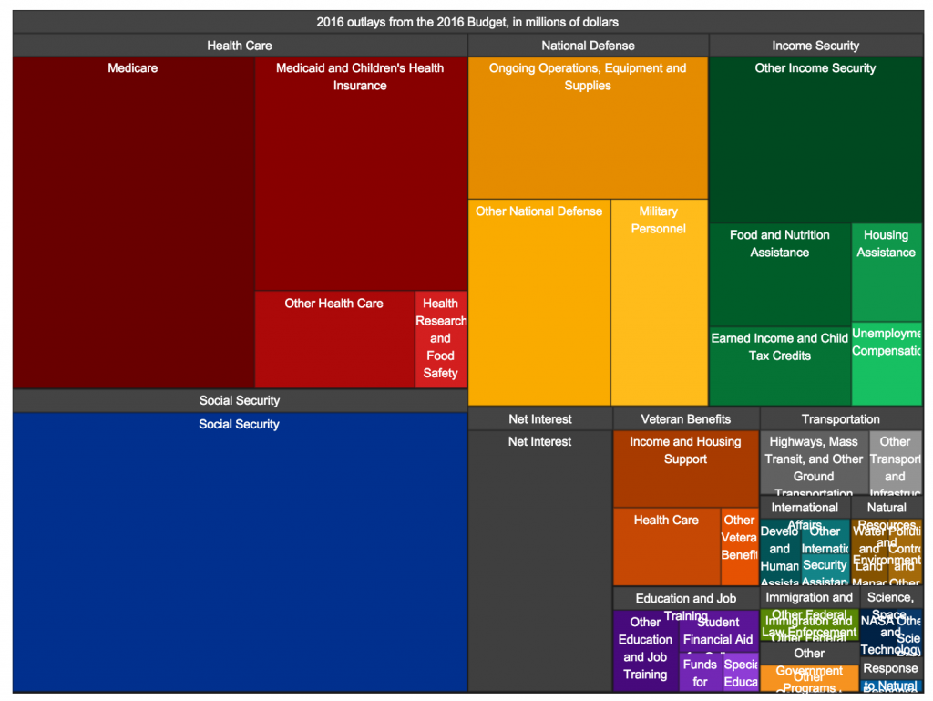

This visual is clearer and cleaner:

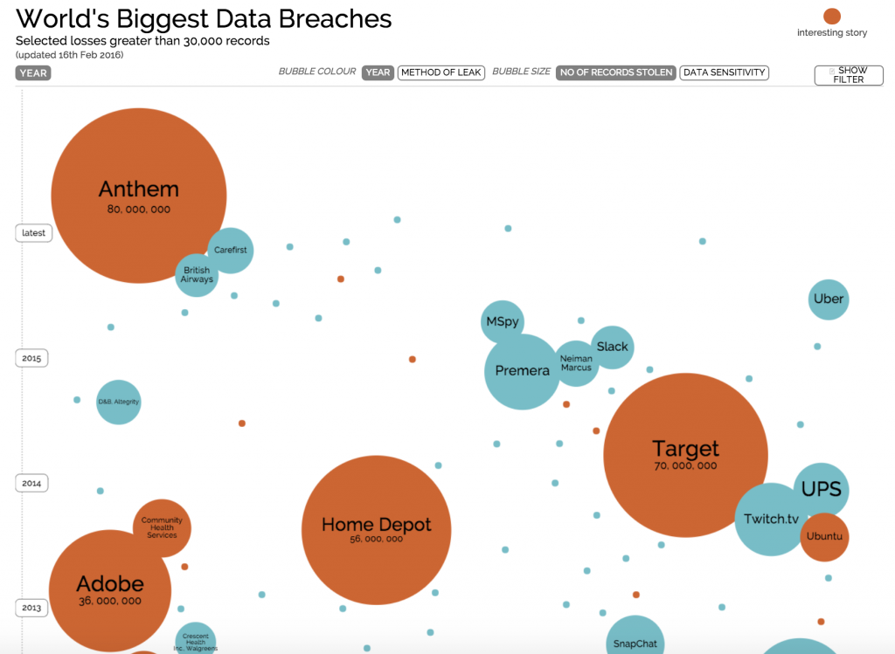

Week 7

Tuftes’d Design and Technique relates to the placement of data, text and visualization in interactive data displays.

The Snapshot below is from Gapminder Org. This was presented in a Ted show. It clearly displays Life Expectancy as it relates to Income per Person year to year. You don’t need to see in interactivity to understand what the data. This design and technique is very clear.

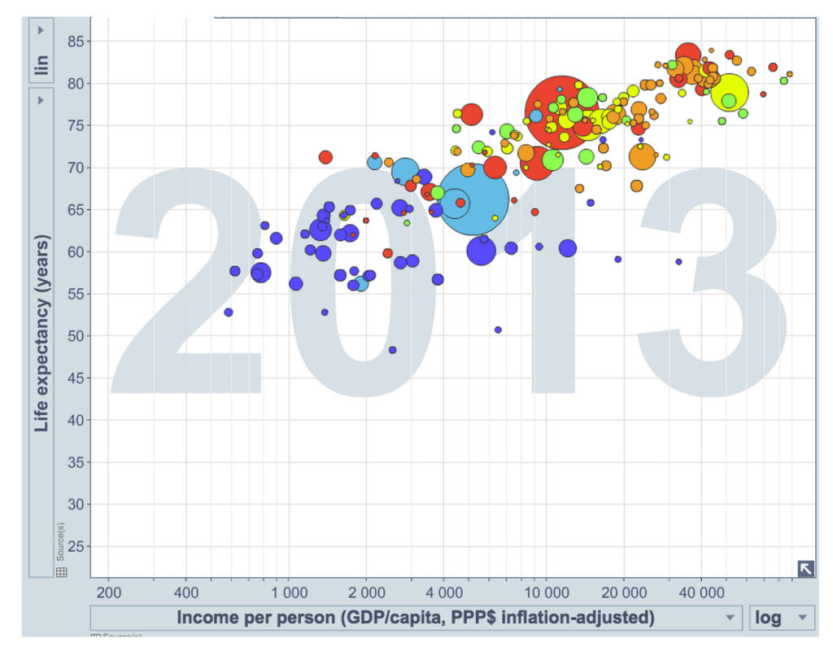

This other design is also very clear. The title is descriptive and table data are labeled for a viewer to easily understand that it is specific to Airbnb properties broken into categories.

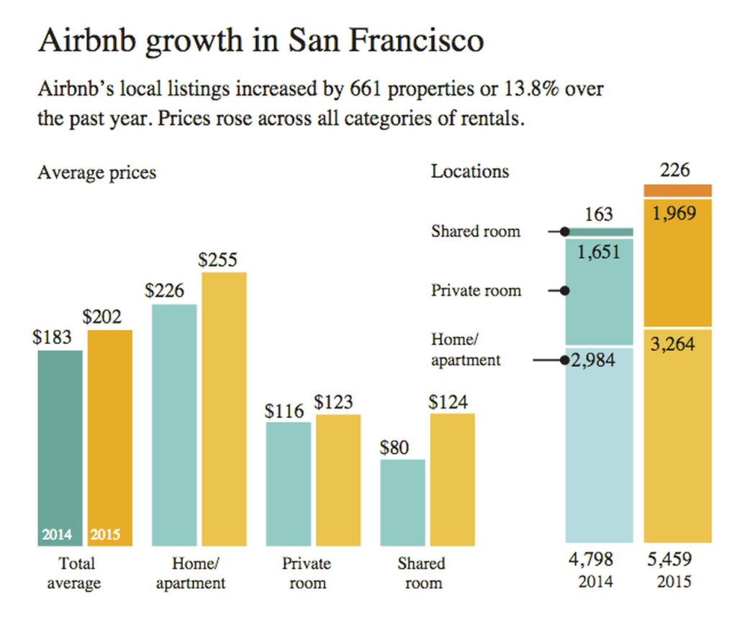

Week 8

Visual Explanations is the third of Edward Tufte's books on information design. The first, **The Visual Display of Quantitative Explanation (1983), is about "pictures of numbers**, how to depict data and enforce statistical honesty**." Envisioning Information (1990) is about "pictures of nouns** (maps and aerial photographs, for example, consist of a great many nouns lying on the ground)." This volume, **Visual Explanations, is about "pictures of verbs**, the representation of mechanism and motion, of process and dynamics, of causes and effects, of explanation and narrative. Since such displays are often used to reach conclusions and make decisions, there is a special concern with the integrity of the content and the design."

Ref: <https://search.proquest.com/openview/9eb4bb61d0b9c7ec60ef55a9c05c3cba/1?pq-origsite=gscholar&cbl=40798>

--------------------------------------------------------------------------------------------------------------------

Visual Explanation is a bit different from the other visualizations, as it tries to explain data in several dimensions with the added dimension of time and motion. In other visualizations you can skim through and get to the meaning of the data fairly quickly. In the example visualizations in this thread, you are forced to slow down to see the data inside the data. In the web this works better with dynamic and interactive images as it keeps the viewer focused on the interactive explanation of the data, rather than focusing on how to connect the dots on a static image.

Week 9

One gif I’ve posted before is the interactive GDP changes per year globally. It is interesting to see how historical events determine growths and declines. It would be nice add some additional data with major news events and see how it correlates to GDP shifts by country.



Week 10

Tooltips adds an additional dimension of data providing text in a less intrusive way then adding static text to a visualization. Tooltips relate to Tuft principles because stabilizes the chart to ink ratio by hiding text until it is useful for the viewer. It also helps enhance the small multiples that Tuft mentions by allowing a viewer to get more descriptive details on smaller images.

Below is a gif with a simple tooltip giving the added description of locations counts.



Week 11

Panning and zooming allow for more visualizations to be added to the page. This feature applies to Tufts “small multiple” since the graphics begin small and expand as you zoom.

The link below has several examples built with SVG:

<https://demos.easypz.io/4060954/>

The image below is one example. As you click each country on the site link, the graphic is zoomed and more information is displayed. This site link also provides the code used to generate the SVG.

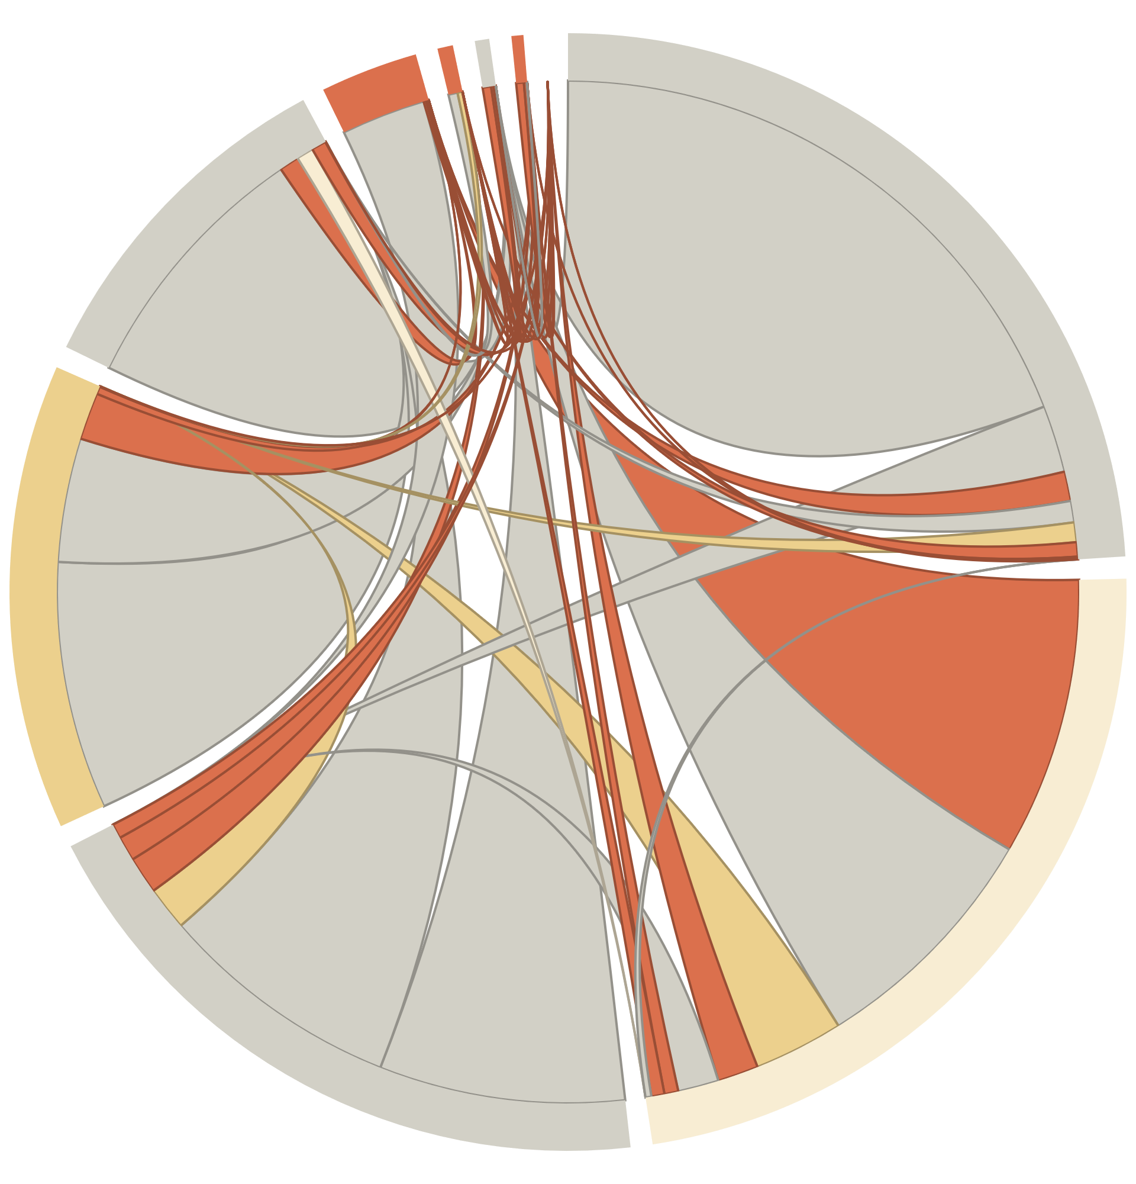

Week 12

Web controls allow multiple dimensions of data to be displayed based on user interaction. In Tufte’s principal, web controls help minimize Chartjunk by displaying data and graphics dynamically only after web control are selected.

There a plenty of tools available to build dashboards by dragging and dropping web controls. Some tools include Visual Studio as well as reporting tools like Qlikview, PowerBI, Crystal reports etc. The below link includes some web administrative tools that utilize dashboards with web controls.

https://colorlib.com/wp/free-dashboard-templates/